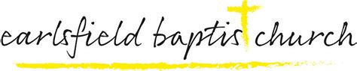
Safeguarding Team

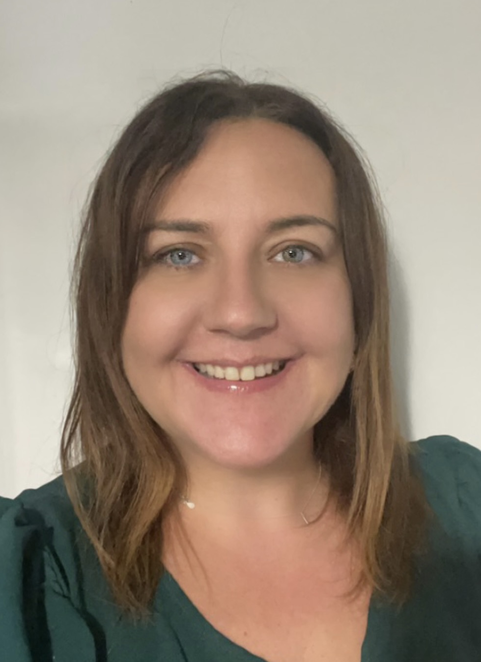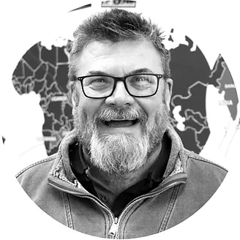

Louise Gilmartin
Designiated Safeguarding Lead
07706286236
Louise.gilmartin@earlsfieldbaptist.org.uk

Rev Keith Parr
Minister DDSl
07999027803
minister@earlsfieldbaptist.org.uk

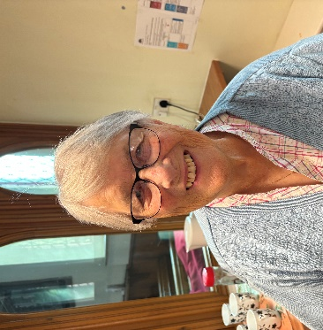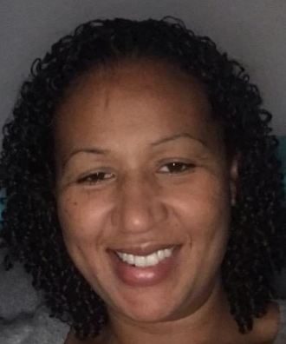
Doreen Dorman
Deacon/ Pastoral Care
07842949854
Zoe Adesuyan
DBS Verifier

